**University**: Jinan University

**Title**: Cartify (shopping application)

**Authors**: Adam Adra, Charbel Bahry

**Supervisor**: DR. Sara Zakariya

**Date**:3/8/2024

# Versions

|  |  |  |  |
| --- | --- | --- | --- |
| Version number | Authors | Date | Notes |
| 1.0.0 alpha | Adam, Charbel | 3/8/2024 | intro |
|  |  |  |  |
|  |  |  |  |

# Abstract

# Table of Contents

# List of Tables

# List of Images

**1. Introduction**

Shopping, a timeless recreational pursuit, has found new dimensions with the advent of online platforms. In this digital landscape, the goal of our expansive application is to craft a dynamic and versatile application interface dedicated to the realm of online retailing. By prioritizing usability and seamlessness, our system aspires to redefine the online shopping experience, transforming it into a journey of convenience, delight, and boundless exploration for users across the virtual marketplace.

* 1. ***Goal******s***
* Enhanced User Experience: Develop a seamless and enjoyable online shopping experience for users, prioritizing ease of navigation and intuitive interface design.
* Advanced Search Functionality: Implement a sophisticated search engine that utilizes machine learning and natural language processing techniques to provide accurate and relevant search results. Users should be able to filter products based on various criteria and preferences.
* Responsive and Interactive Design: Create a responsive application with modern frontend frameworks like Flutter, ensuring smooth and interactive user interactions. Utilize asynchronous data loading techniques to prevent page reloads and enhance performance.
* Streamlined Cart Management: Simplify the shopping cart management process by providing intuitive controls for adding, removing, and updating items. While drag-and-drop functionality can be considered, prioritize mobile-friendly and touch-based interactions.
* Comprehensive Product Information: Offer detailed product descriptions, high-quality images, and user-generated reviews to help customers make informed purchasing decisions. Implement social proof elements like ratings and testimonials to enhance trust and credibility.
* Personalized Recommendations: Leverage data analytics and machine learning algorithms to deliver personalized product recommendations based on user preferences, browsing history, and purchase behavior. Implement features like "You May Also Like" or "Recommended for You" to encourage upselling and cross-selling.
* Seamless Checkout Process: Optimize the checkout process for simplicity and convenience, minimizing friction points and distractions. To accommodate diverse customer preferences, offer multiple payment options, including digital wallets and mobile payment solutions.
  1. ***Need of the application***

There are large numbers of commercial Online Shopping applications offering many products tailored to meet the shopping interests of many customers. These online marketplaces have thousands of products listed under various categories.

**Problem:**

* Lack of Interactivity: Current mobile shopping apps lack interactivity, which diminishes user engagement and satisfaction.
* Traditional User Interfaces with Postbacks: The use of conventional user interfaces leads to frequent postbacks to the server, resulting in delays in displaying results and frustrating user experiences.
* Limited Search Engine Functionality: Many mobile shopping apps lack robust search engines, limiting users' ability to refine search results based on specific parameters effectively.
* Non-User-Friendly Interfaces: Outdated and non-intuitive interfaces hinder users from navigating and interacting efficiently within mobile shopping apps.

**Solution:**

* Enhanced Search Tool: The Mobile Shopping Application aims to provide users with a flexible and powerful search tool, allowing them to create various search criteria combinations for a comprehensive search experience.
* Adoption of Asynchronous Techniques: Leveraging modern asynchronous techniques, such as real-time updates and data loading, the application eliminates unnecessary delays, enabling seamless interaction with the platform.
* Interactive Interface Design: Implement an interactive interface optimized for mobile devices, focusing on intuitive navigation and user engagement. Utilize modern design principles and mobile user experience (UX) patterns to enhance usability.
* Advanced Search Engine: Develop a sophisticated search engine that retrieves relevant products based on user queries and allows users to refine search results using various filters and parameters, ensuring efficient product discovery.
* Drag and Drop Functionality: Introduce intuitive drag-and-drop features that enable users to manage their shopping carts effortlessly. This modern interface element enhances user experience by simplifying the process of adding and removing products from the cart, enhancing overall usability and convenience in the mobile application environment.
  1. ***Scope***
* The current system can be extended to allow the users to create accounts and

save products on to wish list.

* The users could subscribe to price alerts which would enable them to receive

messages when prices for products fall below a particular level.

* The current system is confined only to the shopping cart process. It can be

extended to have an easy-to-use checkout process.

* Users can have multiple shipping and billing information saved. During

checkout, they can use the drag-and-drop feature to select shipping and billing

information.

* User can choose from multiple store location.

## *2.1 UML Modeling for a Shopping Application*

UML (Unified Modeling Language) provides a visual language for representing a software system's structure and behavior. Here's a breakdown of key UML elements for a shopping application:

***2.1.1 Use Case Diagram (Covered in previous response)***

Refer to the explanation and considerations in the previous response (2.1.1) for creating a use case diagram that captures the interactions between actors (Customer, Administrator) and the shopping application's functionalities.

***2.1.1.1 Actors***

* User

***2.1.1.2 Use Cases***

* Search Products
* Filter Products
* View Images
* View Specifications
* View Reviews
* Write Review
* Add to Cart
* Edit Cart

***2.1.1.3 The Use Case Diagram***

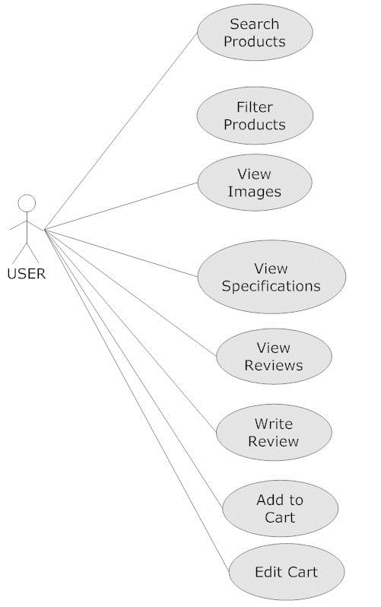

***2.1.1.4 Description***

The use case diagram outlines a typical user journey on an e-commerce website. The user can search for products, filter them based on specific criteria, view product images and specifications, and read or write reviews. They can also add products to a cart and edit the contents of the cart.

***2.2.2 Class Diagram***

***2.2.2.1 Classes***

*User/* Product */* Order */* Inventory */* Payment/ Shopping Cart

**2.2.2.3 *Description***

* **User:** This class represents a user of the e-commerce system. It has attributes like ID, name, and email, and methods like login and logout.
* **Product:** This class represents a product sold on the e-commerce website. It has attributes like product ID, name, price, available quantity, and methods to reduce or increase quantity.
* **Order:** This class represents an order placed by a user. It has attributes like order ID, order date, order status, and methods to add or remove items, calculate the total price, and methods related to placing, shipping, and canceling the order.
* **Inventory:** This class manages the product stock. It has methods to add, remove, and get available products.
* **Payment:** This class handles payment processing. It has methods to process a payment for an order and refund a payment.
* **Shopping Cart:** This class represents a user's shopping cart. It has methods to add, remove items, calculate the total price, and retrieve the shopping cart.

The relationships between the classes are represented by arrows:

* **Contains:** User contains Shopping Cart. This means that a user has one shopping cart.
* **Contains:** Order contains Item. This represents that an order can have multiple items.
* **Association:** User interacts with Order. This means a user can place multiple orders.
* **Association:** Order connects to Payment. This indicates that an order can have one payment.

# 

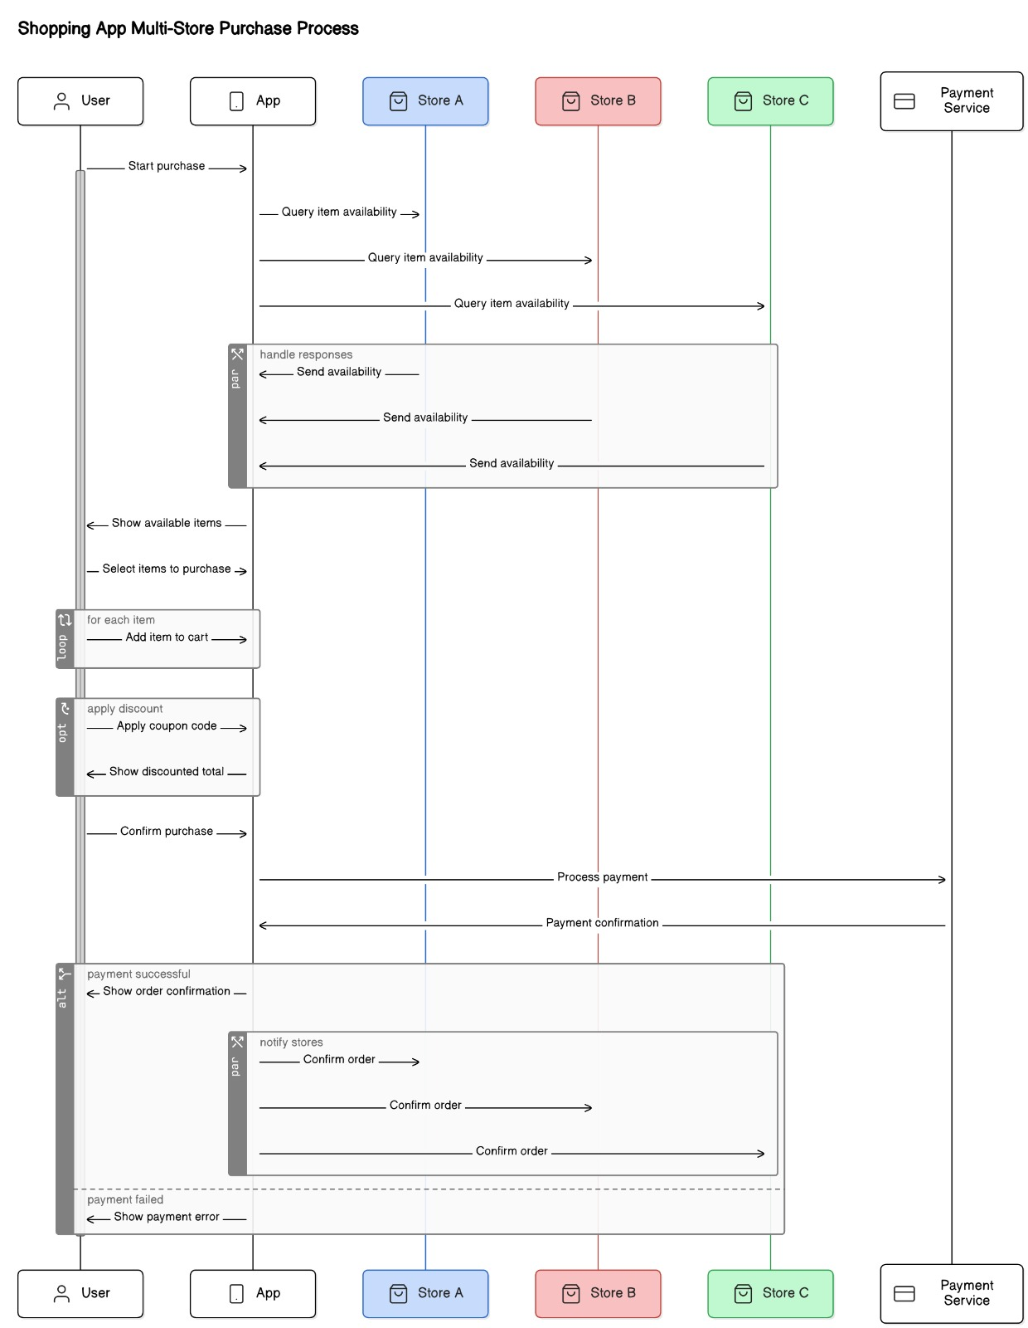

# CHAPTER 2

## UML modeling

## Static modeling

### Use Case Diagram

#### Actors

#### Use cases

#### The use case diagram

#### Description

### Class Diagram

#### Classes

#### The class diagram

#### Description

## Dynamic modeling

### Sequence diagram

### Activity diagram

# CHAPTER 3

## Modeling

# Conclusion

# References

# 